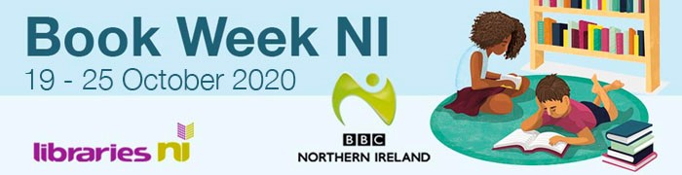
I’m delighted to let you know that Book Week NI will take place during 19 to 25 October and we would really like your school to be involved. We are very grateful to the significant number of schools and school children involved in Book Week NI last year and, though the circumstances are very different, we hope that more will support the goal of encouraging people to read this year.

What is Book Week NI?
Book Week NI is a joint initiative arising from the partnership between BBC Northern Ireland and Libraries NI and the event is now going into its fifth year.
This year’s focus
This year’s theme is Stories and Storytelling; focusing on stories that matter to each one of us and encouraging everyone to participate and share stories from books that matter to them.
The aim is to inspire people of all ages to discover or rediscover the joy of reading by pledging to take 15 minutes to read during and preferably throughout the week. This is particularly prevalent with key messages such as encouraging parents and carers to read and share stories with children.
To encourage this there will be a different theme each day with suggestions of books, eBooks and eMagazines to read. Also, themed displays will take place in libraries across Northern Ireland and the BBC’s programming will link to Book Week NI across its air waves. More information on the themes is available on our website here.

Here’s how your school can get involved:
- Show the world you’re taking part
Show the world your pledging to take 15 minutes to read each day by uploading our pledge button to your website or social media channels. You can download the pledge button here.
- Make use of our Reading Record Cards
We’ve created reading records for children to keep track of what they read during Book Week. These are available to download directly from our website https://bit.ly/BookWeekNIResources​
Engage on social media
Take a selfie with a book that relates to the theme, or if you prefer take a short video clip. Then upload the photo/video to social media.
For example:
- During #BookWeekNI my #Take15 is ……
- #BookWeekNI my favourite children’s book is …..
- Pupils from class 8a’s #BookWeekNI recommended read is #Matilda
Remember to tag Libraries NI and BBC Northern Ireland using
- @LibrariesNI and @BBCnireland on Twitter
- @LibrariesNorthernIreland and @BBCNI on Facebook
- @librariesni and @bbcni on Instagram
Don’t forget to tag in the authors, you might get a retweet and/or a like!
- Help spread the word…
You’ll find a range of downloadable resources on our website here. These include posters, fliers and social media graphics. There are also resources that you can use in school such as recommended reads and quizzes.
We are hoping to include as many people as possible in this year’s Book Week NI and as an important stakeholder I do hope you will get involved.
Best Wishes
Jim O’Hagan, Chief Executive
