A Summer to Remember!

We live in such a beautiful country, and you do not need to spend lots of money to make this a summer to remember! Here are some helpful tips and ideas for walking, cycling, and scooting this summer:
Cycling: Beautiful countryside, stunning shores and lakes and wonderful mountains make Northern Ireland a perfect place to enjoy a family day out cycling. Check out our web pages for lots of ideas and tips:
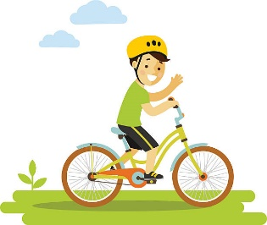
Where to cycle: Where to cycle with kids in NI
Find a route: Find a route in NI
Teach your child to ride without stabilisers: Teach a child to ride without stabilisers
Read a story about Bikepacking with kids: Things I learnt bikepacking with kids
Walking: Whether you want a coastal or lakeside walk, a mountain or forested walk, a countryside or urban walk, you have plenty of choice. Why not pack a picnic and check out these web pages:
City walks: City walks on the National Cycle network
Safety tips for children: Walking safety tips for children
Walking routes: Walk Listings - WalkNI

Scooting: Scooting is healthy and environmentally friendly, and another brilliant way to get out this summer to enjoy our beautiful countryside. Check out our tips on learning how to scoot:
How to scoot: Learn how to ride a scooter

