Friends of Chapel Road PS

Would like to invite you to join us for our

Cash for Kids Schools challenge

You will also have the chance to

**Beat the Buzzer**

50p for 3 goes 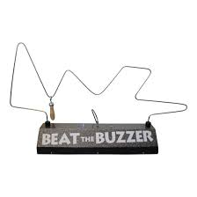



Second Hand Book Sale



Friday 20th October 2023

Garden Room

Prices will vary